|  |  |
| --- | --- |
| **Soal Praktikum**  *Practicum Case* | LogoBINUS-University |
| M0114  Web – Based Programming |
| **Teknik Informatika**  *Computer Science* | **O1-M0114-DL01** |
| **Periode Berlaku** Semester Ganjil 2013/2014  ***Valid on*** *Odd SemesterYear 2013/2014* | **Revisi 01**  *Revision 01* |

## Learning Outcomes

* Choose appropriate programming language techniques to deal with the user requirements
* Build website applications

## Topic

* Session 2 - HTML – Tables and Links

## Sub Topic

* **Link**
* **Target attributes**
* **List**
* **Table**
* **Table formatting**
* Frameset
* Meta

## Soal

*Case*

**BlueJack Foodhall** was firstly opened in March 1991 with the goal of providing great food, great services at an affordable price. We focus on customer's loyalty and satisfaction. We believe in making every dining experience memorable, so that the customers will keep coming back for more, since the key to be a successful restaurant business is to provide a great and positive customer experience.

**BlueJack Foodhall** serves many different varieties of Asian, Indonesian, and West cuisine, such as our favorite Chicken Tacos, Geso Karaage, Wings Over Buffalo, Cajun Chicken Pasta, and many more. Our highly trained and experienced executive chefs from Japan and England dish up all of our delicious menus.

As the growth of the information technology **Bluejack Foodhall** wants to make an online system to provide any information about **Bluejack Foodhall** and **Bluejack Foodhall** choose website as the media. Therefore, you are asked to create a website with your own creativity using **HTML** and **Javascript** using these following criteria:

* **Link**, you can use **<a></a>** to make a navigation to other page.
* **List**, you can make a data list using **<li></li>**.
* **Table**, you can make a table in your website using **<table></table>.**

Further description about **Bluejack Foodhall** website:

1. Home page contains little information about **Bluejack Foodhall**. You can see the Home page as the following image:

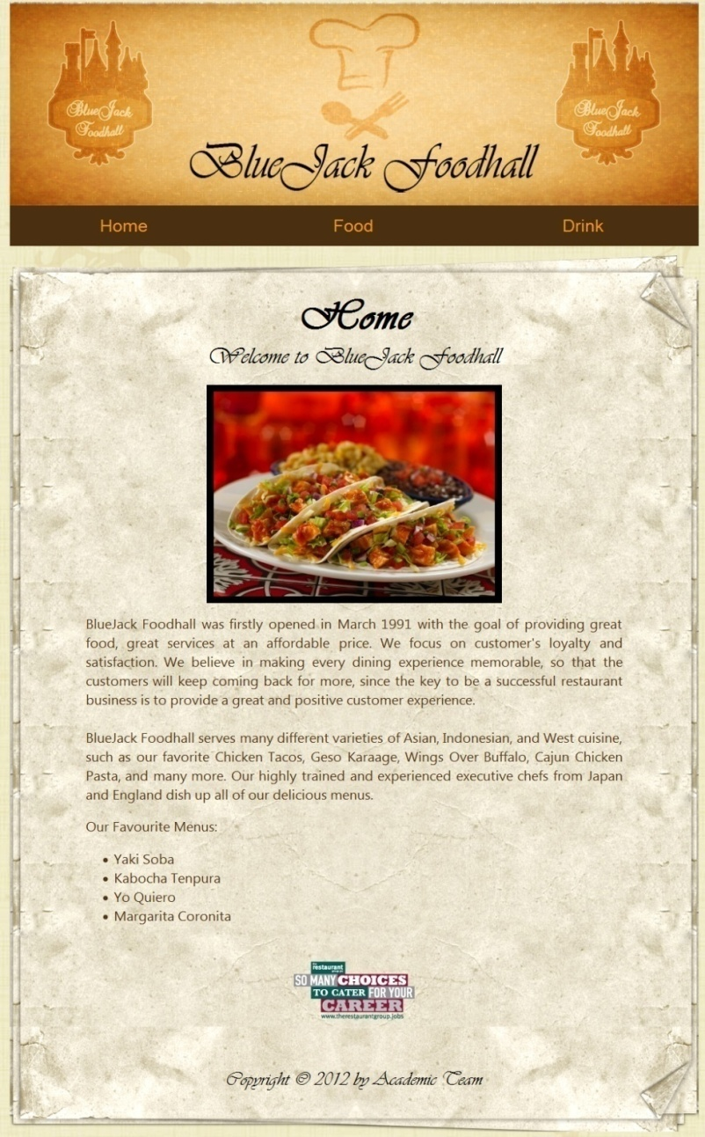

Home Page

1. Food page contains information about food that **Bluejack Foodhall** offers to customer. You can see the Food page as the following image:

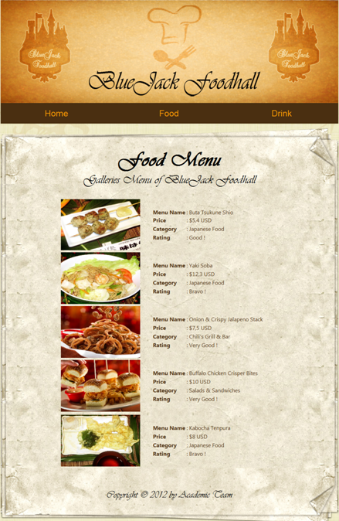

Food Page

1. Drink page contains information about all drink that **Bluejack Foodhall** offers to customer. You can see the Drink page as the following image:

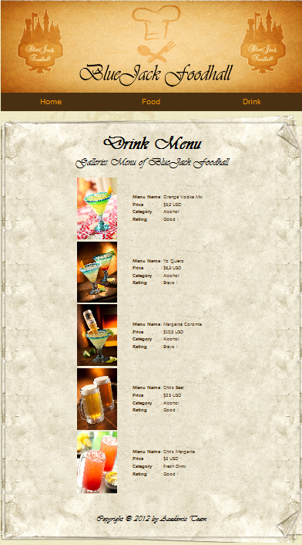

Drink Page

**References:**

<http://imageshack.us/photo/my-images/809/bgdeco.png/>

<http://imageshack.us/photo/my-images/269/bgpattern.jpg/>

<http://www.facebook.com/media/set/?set=a.329237152126.155946.100085252126&type=3>

<http://www.facebook.com/media/set/?set=a.114856113213.100578.106027143213&type=3>

<http://www.facebook.com/media/set/?set=a.115346023213.100815.106027143213&type=3>

<http://www.facebook.com/media/set/?set=a.115340378213.100811.106027143213&type=3>

<http://www.facebook.com/media/set/?set=a.10150924282833214.406645.106027143213&type=3>

<http://www.hospitalityandcateringnews.com/2012/07/chef%E2%80%99s-restaurant-of-the-week-the-queens-at-belbroughton/>

<http://www.hi-tech.com.tr/bir-sef-nasil-olmali/>

<http://www.dustinmillermedia.com/>

<http://www.garfunkels.co.uk/>